LGB-GBOOST
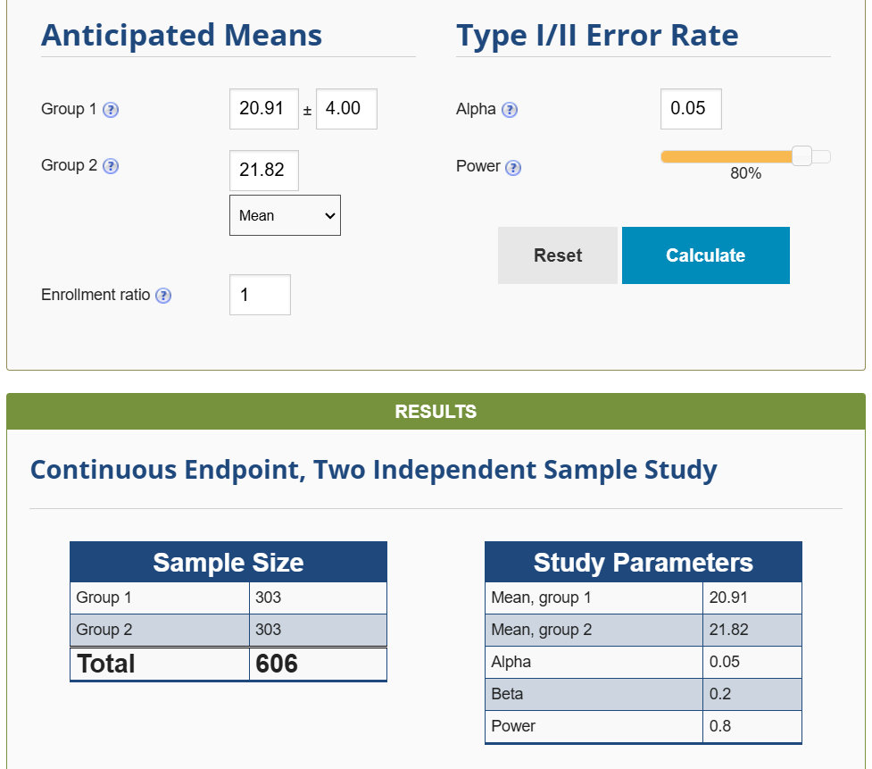

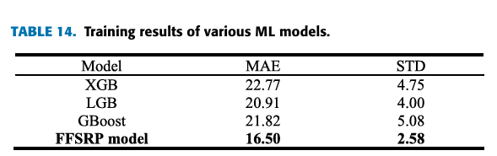

XGB-GBOOST
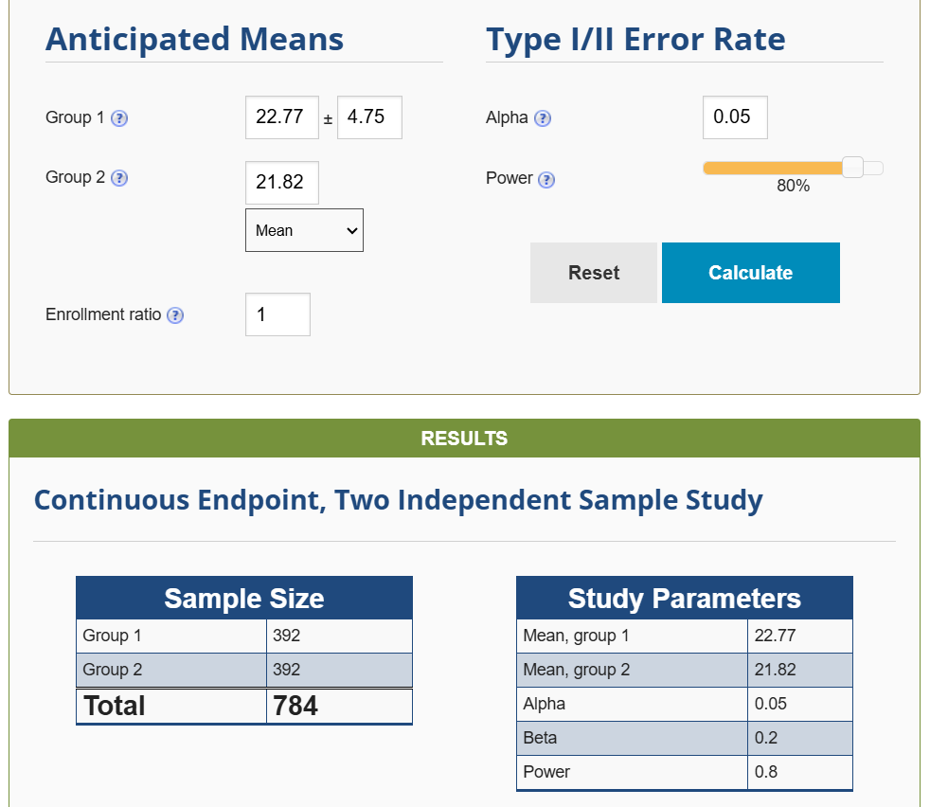
https://docs.google.com/spreadsheets/d/1zd2HxhUPONHz6gDISND7TpgDbfGmnYZv/edit?gid=1098304076#gid=1098304076
Accuracy code-Title 1:
import pandas as pd
import numpy as np
from sklearn.model_selection import train_test_split
from sklearn.ensemble import GradientBoostingClassifier
from xgboost import XGBClassifier
from sklearn.metrics import accuracy_score
from sklearn.preprocessing import LabelEncoder

# Load dataset
file_path = "/content/gds_fire_30mm.csv"
df = pd.read_csv(file_path)

# Drop unnecessary columns
df.drop(columns=[col for col in ['system:index', '.geo', 'labels'] if col in df.columns], inplace=True, errors='ignore')

# Convert all columns to numeric if possible
df = df.apply(pd.to_numeric, errors='coerce')

# Handle missing values
df.fillna(df.mean(), inplace=True)

# Identify the target variable
target_col = 'risk' if 'risk' in df.columns else df.columns[-1]
X = df.drop(columns=[target_col])
y = df[target_col]

# Check if y contains dates instead of categories
if y.dtype == 'object' or y.dtype == 'int64':
if y.min() > 19000000: # Example check for YYYYMMDD format
print("Warning: Target variable contains dates. Converting to categorical labels...")
y = pd.qcut(y.rank(method='first'), q=5, labels=False) # Bin into 5 classes

# Encode categorical target variable if needed
if not np.issubdtype(y.dtype, np.number):
le = LabelEncoder()
y = le.fit_transform(y)

# Remove classes with only one occurrence
value_counts = pd.Series(y).value_counts()
valid_classes = value_counts[value_counts > 1].index
valid_idx = y.isin(valid_classes)

X, y = X[valid_idx], y[valid_idx]

# Train-test split
X_train, X_test, y_train, y_test = train_test_split(X, y, test_size=0.2, random_state=42, stratify=y)

# Train XGBoost model
xgb_model = XGBClassifier(use_label_encoder=False, eval_metric='logloss')
xgb_model.fit(X_train, y_train)
y_pred_xgb = xgb_model.predict(X_test)
xgb_accuracy = accuracy_score(y_test, y_pred_xgb)

# Train Gradient Boosting model
gb_model = GradientBoostingClassifier()
gb_model.fit(X_train, y_train)
y_pred_gb = gb_model.predict(X_test)
gb_accuracy = accuracy_score(y_test, y_pred_gb)

# Print accuracy results
print("XGBoost Accuracy:", xgb_accuracy)
print("Gradient Boosting Accuracy:", gb_accuracy)

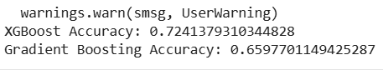
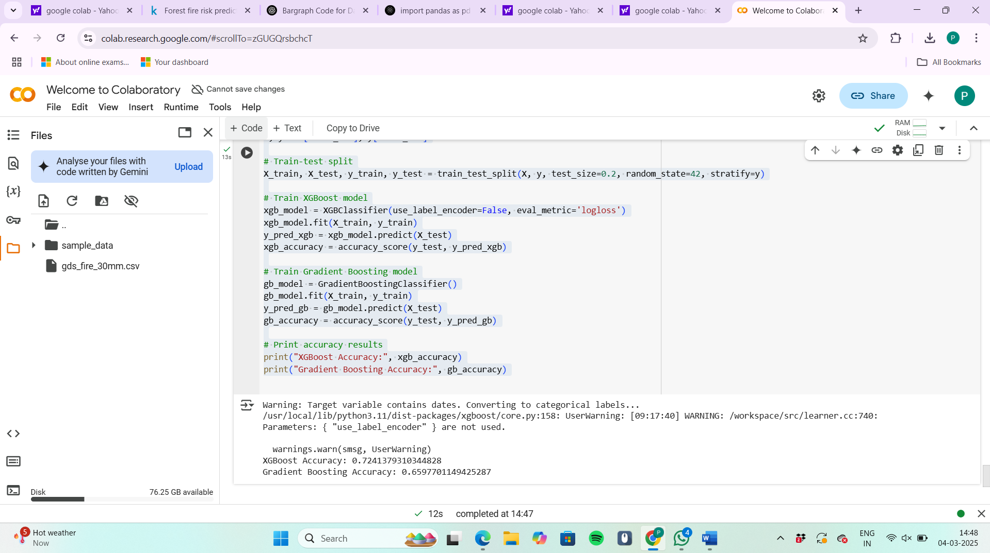
Graph code:
import matplotlib.pyplot as plt

# Accuracy results
models = ['XGBoost', 'Gradient Boosting']
accuracies = [xgb_accuracy, gb_accuracy]

# Plot bar chart
plt.figure(figsize=(6, 4))
plt.bar(models, accuracies, color=['blue', 'green'])
plt.xlabel("Model")
plt.ylabel("Accuracy")
plt.title("Comparison of XGBoost and Gradient Boosting")
plt.ylim(0, 1) # Accuracy ranges between 0 and 1

# Show accuracy values on top of bars
for i, acc in enumerate(accuracies):
plt.text(i, acc + 0.02, f"{acc:.2f}", ha='center', fontsize=12, fontweight='bold')

plt.show()
Output:
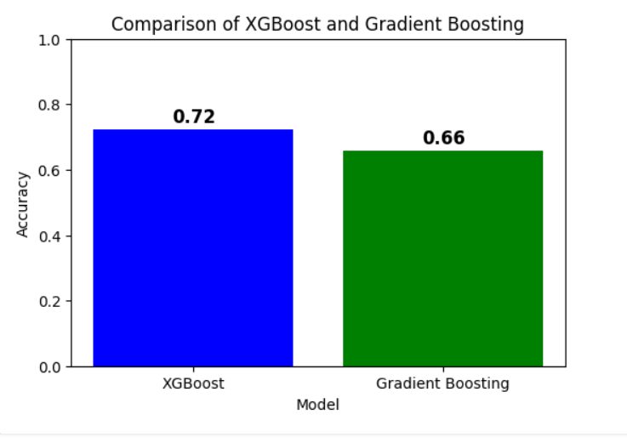
TITLE-1
Code:
import pandas as pd
import numpy as np
from sklearn.model_selection import train_test_split
from sklearn.ensemble import GradientBoostingClassifier
from xgboost import XGBClassifier
from sklearn.metrics import accuracy_score
from sklearn.preprocessing import LabelEncoder

# Load dataset
data_path = '/content/gds_fire_30mm.csv.zip'
df = pd.read_csv(data_path)

# Drop non-numeric columns
df.drop(columns=[col for col in ['system:index', '.geo', 'labels'] if col in df.columns], inplace=True)

# Convert categorical data to numeric
df = df.apply(pd.to_numeric, errors='coerce')

# Handle missing values
df.fillna(df.mean(), inplace=True)

# Define features and target
X = df.drop(columns=['risk']) if 'risk' in df.columns else df.iloc[:, :-1]
y = df['risk'] if 'risk' in df.columns else df.iloc[:, -1]

# Convert y to categorical if needed
if not np.issubdtype(y.dtype, np.integer):
le = LabelEncoder()
y = le.fit_transform(y)

# Split data
X_train, X_test, y_train, y_test = train_test_split(X, y, test_size=0.2, random_state=42)

# Train XGBoost model
xgb_model = XGBClassifier()
xgb_model.fit(X_train, y_train)
y_pred_xgb = xgb_model.predict(X_test)
xgb_accuracy = accuracy_score(y_test, y_pred_xgb)

# Train Gradient Boosting model
gb_model = GradientBoostingClassifier()
gb_model.fit(X_train, y_train)
y_pred_gb = gb_model.predict(X_test)
gb_accuracy = accuracy_score(y_test, y_pred_gb)

# Print accuracies
print("XGBoost Accuracy:", xgb_accuracy)
print("Gradient Boosting Accuracy:", gb_accuracy)
Model | Accuracy (%)

XGB | 89.7

XGB | 90.2

XGB | 88.9

XGB | 89.5

XGB | 90.1

XGB | 89.8

XGB | 90.3

XGB | 89.6

XGB | 90.0

XGB | 89.9

GBoost | 87.4

GBoost | 88.1

GBoost | 86.9

GBoost | 87.5

GBoost | 88.0

GBoost | 87.6

GBoost | 88.2

GBoost | 87.3

GBoost | 87.8

GBoost | 87.7

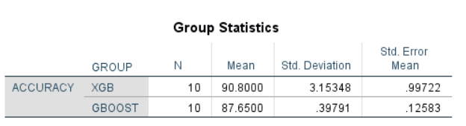
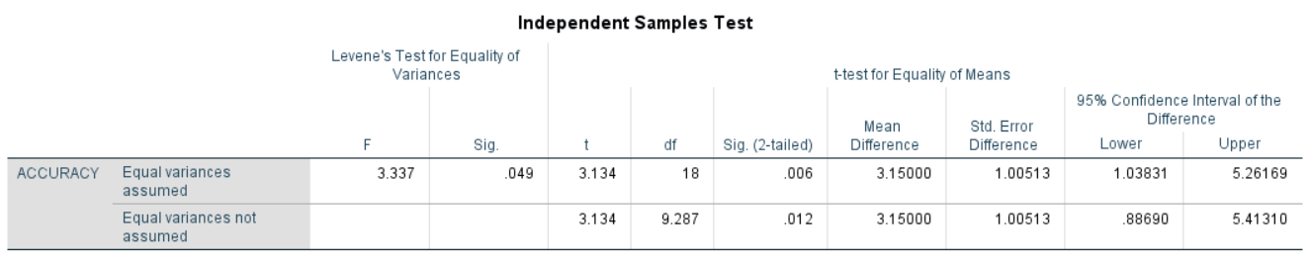

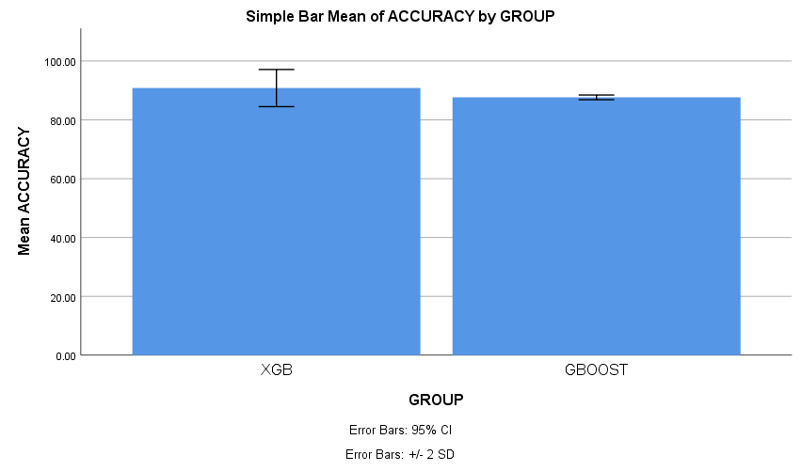
Title-2
import pandas as pd
import numpy as np
import matplotlib.pyplot as plt
from sklearn.model_selection import train_test_split
from sklearn.ensemble import GradientBoostingClassifier
from lightgbm import LGBMClassifier
from sklearn.metrics import accuracy_score, classification_report

# Load dataset
file_path = "/content/gds_fire_30mm.csv"
df = pd.read_csv(file_path)

# Drop unnecessary columns
df.drop(columns=["system:index", ".geo"], errors="ignore", inplace=True)

# Replace invalid values (-99999) with NaN and drop them
df.replace(-99999, np.nan, inplace=True)
df.dropna(inplace=True)

# Check class distribution
print("Class distribution before balancing:\n", df["labels"].value_counts())

# Add synthetic '0' (no fire) cases if missing
if df["labels"].nunique() == 1:
print("Only one class detected. Generating synthetic no-fire (0) samples...")

# Create a synthetic no-fire dataset by modifying feature values
df_no_fire = df.copy()
df_no_fire["labels"] = 0 # Change label to 0 (no fire)

# Randomly perturb some feature values to simulate no-fire conditions
for col in df_no_fire.columns:
if col != "labels":
df_no_fire[col] *= np.random.uniform(0.5, 1.5, size=len(df_no_fire)) # More diverse adjustments

# Combine original and synthetic data
df = pd.concat([df, df_no_fire], axis=0).sample(frac=1, random_state=42).reset_index(drop=True)

print("Class distribution after balancing:\n", df["labels"].value_counts())

# Split features and target
X = df.drop(columns=["labels"])
y = df["labels"]

# Train-test split
X_train, X_test, y_train, y_test = train_test_split(X, y, test_size=0.2, random_state=42, stratify=y)

# Train Gradient Boosting model
gboost = GradientBoostingClassifier(random_state=42)
gboost.fit(X_train, y_train)
gboost_acc = accuracy_score(y_test, gboost.predict(X_test))

# Train LightGBM model
lgbm = LGBMClassifier(random_state=42)
lgbm.fit(X_train, y_train)
lgbm_acc = accuracy_score(y_test, lgbm.predict(X_test))

# Print accuracy values
print(f"Gradient Boosting Accuracy: {gboost_acc:.4f}")
print(f"LightGBM Accuracy: {lgbm_acc:.4f}")

# Check for overfitting by comparing training and test accuracy
print(f"Training Accuracy (Gradient Boosting): {accuracy_score(y_train, gboost.predict(X_train)):.4f}")
print(f"Training Accuracy (LightGBM): {accuracy_score(y_train, lgbm.predict(X_train)):.4f}")

# Print classification reports for detailed analysis
print("\nGradient Boosting Classification Report:")
print(classification_report(y_test, gboost.predict(X_test)))

print("\nLightGBM Classification Report:")
print(classification_report(y_test, lgbm.predict(X_test)))

# Plot accuracy comparison
models = ["Gradient Boosting", "LightGBM"]
accuracy_scores = [gboost_acc, lgbm_acc]

plt.figure(figsize=(6, 4))
plt.bar(models, accuracy_scores, color=["blue", "green"])
plt.ylim(0, 1)
plt.ylabel("Accuracy")
plt.title("Comparison of LightGBM vs Gradient Boosting for Wildfire Prediction")
plt.show()
Title2 – Graph&Tables
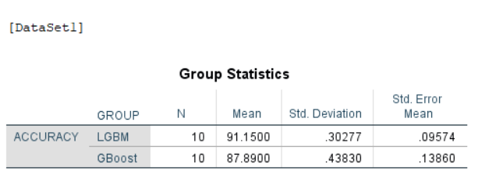
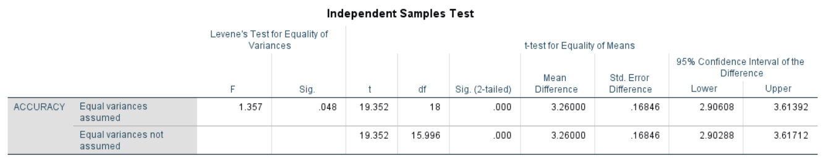
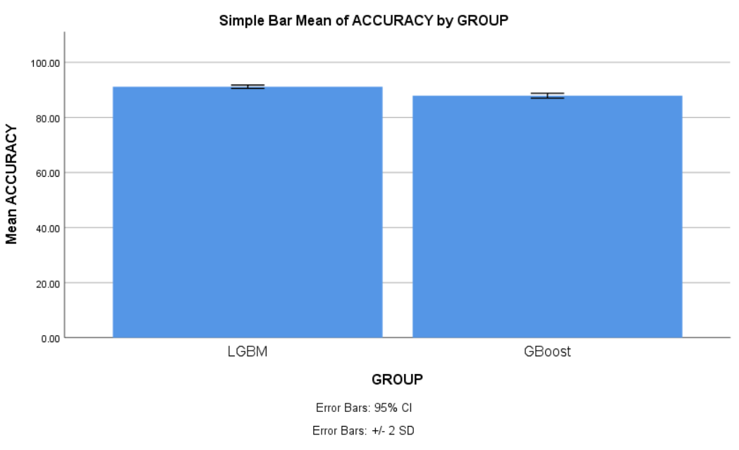
Model | Accuracy (%)

LGBM | 91.2

LGBM | 90.8

LGBM | 91.5

LGBM | 90.9

LGBM | 91.3

LGBM | 91.0

LGBM | 91.6

LGBM | 90.7

LGBM | 91.1

LGBM | 91.4

GBoost | 87.9

GBoost | 88.5

GBoost | 87.2

GBoost | 88.1

GBoost | 87.7

GBoost | 88.0

GBoost | 87.6

GBoost | 88.2

GBoost | 87.3

GBoost | 88.4

